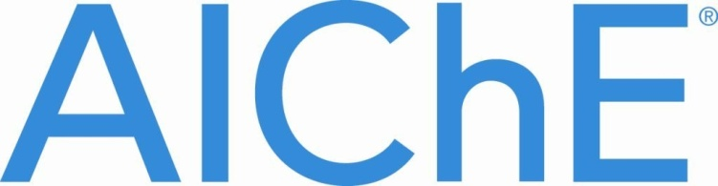
2012 ScaleUp Sponsor Awards
Under the aegis of AIChE and its ScaleUp Program, a number of ScaleUp corporate sponsors are awarding $500 scholarships which may be used as travel stipends for this year’s AIChE Annual Student Conference. To qualify, students must have a declared major in chemical engineering and complete a written essay on one of the following topics as determined by the corporate sponsor:
- CHEVRON -- “How Would You Change Our Government’s Current Energy Policy to Benefit Both Our Communities and the Energy Industry?”
Submit essay of approx. 250 words, resume and unofficial transcript to Tarin@chevron.com.

- CORNING -- Please choose one (1) of the following topics: 1) “Best Design Practices and Process Safety for HF Handling Systems”; 2) “Ion Exchange in Glasses”; 3) “Strength of
Inorganic Glasses”; 4) “Acid Etching of Glasses.”
Submit essay of approx. 500 words to micma@aiche.org.

- DOW CHEMICAL -- “Describe How You, As a Chemical Engineer, Would Approach Such Challenges As the Need for Clean Water, Renewable Energy Generation and Conservation, and Increasing Agricultural Productivity While Embracing the Principles of Sustainability.”
Submit essay of approx. 500 words to micma@aiche.org.

- UOP/Honeywell -- “When Will We Run Out Of Oil?”
Submit essay of approx. 500 words to micma@aiche.org.

Deadline for submissions: MAY 31, 2012

