AIChE Meeting Minutes
April 16, 2014

- Mid-Atlantic Conference
  - At UVA
    - Good for networking/made good friends and connections
    - Brought back new ideas for the club, especially from talking to our former president, Owen
    - Observed Chem-E car competition firsthand
- Chem-E Car
  - Shoebox-sized vehicle powered by chemical reactions
    - Some video examples shown
  - Has to travel certain distance and then stop (this can vary each competition)
  - Our car
    - Uses stirling engine (heat engine) and a temperature difference
      - H2O2 decomposition for the hot side and dry ice/ acetone reaction for the cold side
    - Opportunities to be involved:
      - Reactions must be tested
      - Stirling low torque and high speed
      - Install gearbox and chassis
      - Constant temperature requires constant reactant flow
      - Heat engine requires heat flow
      - Timing system required
    - We meet Sundays at 4pm and sometimes Wednesdays at 8pm.
- Omega Chi Epsilon
  - Honor Society of Chemical Engineers
  - Recognizes achievements, both scholastic and personal, of ChemEs
  - Fosters many opportunities
  - Recognition to the Chem-E department and Stevens Faculty
  - Current progress for our chapter
    - Working on proposal to present to faculty and student life
    - We need signatures on our petition!
    - Next step is colonization, then form a chapter
    - Should be done within 2 years
- T-Shirts
  - Cost: will be around $10
  - 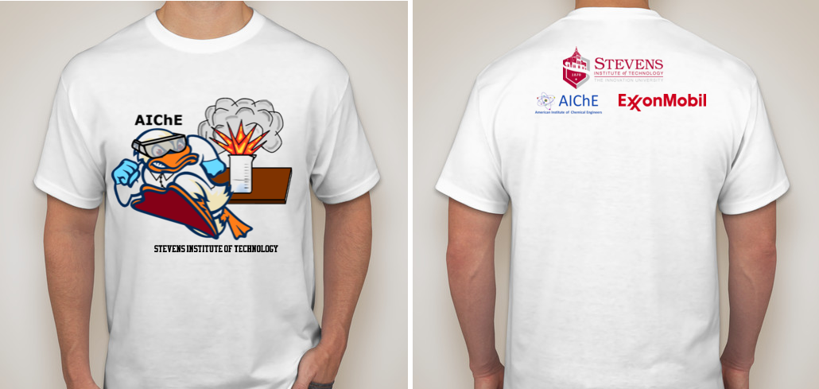
- Peer Mentor Program & Plant Tours
  - Peer mentor
    - Assist ChemE students with courses and non-ChemE as a part of Omega Chi Epsilon
    - Possible study sessions?
  - Plant Tours
    - First-hand experience into chemical engineering
    - Creates relationships with companies and develops resume
    - Infineum
      - Palash is planning a tour (possible Fall Semester)
      - Located in Linden, NJ
      - LET US KNOW IMMEDIATELY IF YOU ARE INTERESTED
- Housekeeping Items
  - Website
- URL: http://ugstudentlife.stevens.edu/org/aiche
- Development of Website and Ducksync to begin for Fall 2014
- Website to include:
    - ChemE Car
    - Campus/Outreach Events
    - Peer Mentor Schedule
    - Calendar for Semester
    - Officer Contact List
    - Got Ideas or Comments? Email rletona@stevens.edu
  - AIChE National Registration
    - Make sure to register for membership for great benefits
    - www.aiche.org
- Upcoming Events
  - ChemE semi in Fall 2014
  - Mixer with Faculty
  - BBQ for fall semester
  - In Situ soil remediation talk
    - Monday April 21st 5:30-7:30 @ Pfizer Building
    - Speaker: Michael Wagner on Latest Remediation technologies for in-situ cleaning of soil contamination
  - CONTACT RAUL LETONA IMMEDIATELY IF YOU WANT TO GO. @ rletona@stevens.edu

