McDermott – Lummus Technology
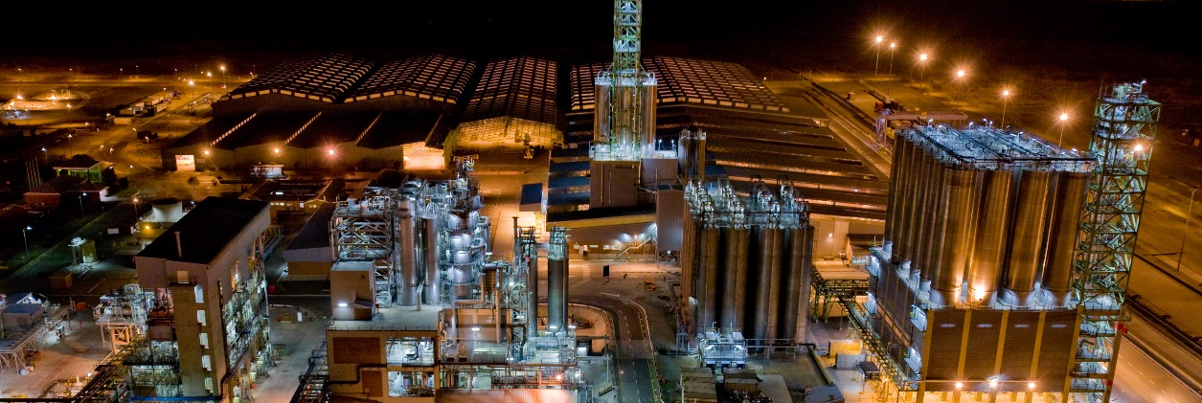
Stevens Institute Campus Interview Information:

Information Session:
Wednesday, September 12, 2018 from 5:00 – 7:00pm in Fielding (3rd floor of Howe Center)

On CAMPUS RECRUITING:

Please apply to our job posting on https://app.joinhandshake.com/

Apply End
Sunday, September 16, 2018 at 11:59 pm

On CAMPUS Interview Date
Friday, September 28, 2018
Lummus Technology is hiring process engineers who will participate in a two year rotational program where they will be exposed to various Petrochemical and Refining & Gasification technologies that are in our broad portfolio. Before their first rotation, they will participate in an extensive four week training program that will prepare them for their first assignment.

During the training program our new engineers complete a training project, based on an actual Lummus Technology project, which develops the skills needed to transition smoothly into a first job assignment and reinforces key chemical engineering concepts learned in school. The simulated project environment allows trainees to collaborate and network with other new hires and experienced engineers alike, with lectures and demonstrations from experts and leaders within the company as well as unstructured time to work on weekly project goals. Lummus Technology engineers are better prepared than ever to contribute right away to important projects and start their career in our technology industry.
Lummus Technology Recruiting Contacts:

Norah Abdallah
Process Engineer
973-893-2129
Norah.r.abdallah@mcdermott.com

Madison Annitto
Process Engineer
973-893-2146
Madison.annitto@mcdermott.com

Marcie Babbitt
HR Manager
973-893-2015
Marcie.babbitt@mcdermott.com

Vera Coleman
HR Admin
973-893-2112
Vera.coleman@mcdermott.com

McDermott Intl Inc.
Lummus Technology
1515 Broad Street
Bloomfield, NJ 07003
TEL: 973-893-1515
www.mcdermott.com

Process Engineer Job Description
Lummus Technology process engineers perform process and systems engineering on projects, proposals and studies and are trained on the company’s methods, computer tools, standards and procedures for a successful career in our licensing business.

Requirements:
- BSChE degree minimum requirement
- Typically has 0 - 2 year of experience
- Familiar with computer software such as spreadsheets and Microsoft office suite
- Familiar with commercial simulation software
- Database experience a plus
- Ability to work in teams
- Good verbal and written communication skills
- Ability to travel
- Strong presentation skills needed
- Creative and innovative thinker
Job Description:
- Performs process design simulations
- Prepares equipment and instrument data sheets
- Prepares process flow diagrams
- Prepares piping and instrument flow diagrams
- Conducts technical presentations
- Organizes, tracks and prepares summary reports, job documentation and job material as required
- Uses the principles of quality as an integral part of the work process which includes CMS
- Fosters Innovation
Exposure to:
- Proposal Generation
  - Process Configurations, Process Kinetics, Catalyst Selection, Reactor Sizing, Product Yields and Properties and Utilities
- Process Design
  - Heater Process Design, Simulation, Heat & Material Balance, Process Flow Diagrams, Equipment Sizing, Catalyst Requirements and Reviewing/Developing the Basis of Design Documents
- Systems Engineering
  - P&I Development, Hydraulics/Line Sizing, Equipment Design, Instrumentation, Flare Load Calculations, and Safety Valve Calculations & Specifications
- Computer design tools and databases
  - Process Simulation (Pro II), Process Simulation (Unisim), Material balance Equipment data Sheet, Column Sizing, Preparing Process Specifications, Equipment Sizing, and Hydraulic Calculations

