- Call to order
  - The General Body Meeting of the Filipino Association of Stevens Tech was called to order at 9:10pm on 10/31/2011in BC 210 by Cerille Avetria.
- Roll Call
  - Present: cavetra, jdrosos, mumali, kgilbert, plai, jalicant, jkim, khon, aumali, ateano, allamanz, nlim, mwalker, efernan, sgayanil, jmalasig, bma, rflores, cdinh, cpogata, dchin, tfederen, carcilla, efernan1, gflores, arodrig2, rsabale
  - Absent:
  - Excused: lhuang, areyes, jyoung
- Approval of Minutes

- Officer Reports
  - President (cavetria)
  - Vice-President (jdrosos)
  - Treasurer (kgilbert)
  - Secretary (mumali)
    - Sign the attendance!
  - Social (nlim)
  - ESC Rep (efernan1)
  - FIND Rep (kmarti)

- Unfinished Business

  - FIND
    - When: THIS WEEKEND Nov 4-6 @Cornell University
    - Hotel: Ramada – 3 rooms (1 double room, 2 king)
    - Cost: none, except bring $$$ for food & gas!

    - Friday:
      - Departure time: around 4pm
      - Registration/On-site registration at Cornell

    - Saturday:
      - Opening Ceremony: 10am
      - Workshops/dialogue

    - Sunday:
      - Checkout: 12pm

    - Opening Chant: http://www.youtube.com/watch?v=DJeudlrKg7A
    - Closing Chant: http://www.youtube.com/watch?v=QZhfL9Wt-QU

- New Business
  - Games Night w/ CSA & KSA
    - When: Thursday, November 3 @9pm
    - Where: Hayden Lounge
    - Prizes, Snacks, and Fun!
    - 1st Prize: 3G Keyboard Kindle
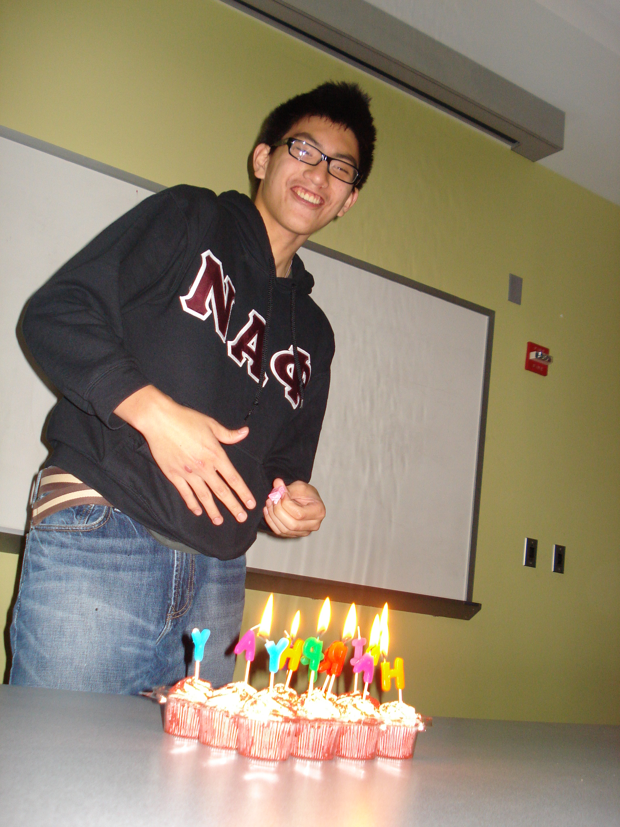
- Announcements

Happy birthday,
Kevin Marti!

- Adjournment
  - Meeting was adjourned at 9:55pm by Cerille Avetria. The next General Body Meeting is 11/14/2011!

- Minutes by: Milcah Umali
“Love what you do.” –Dove chocolate wrapper[:

