Formation of b ions from protonated peptides

INTRODUCTION

Peptides are biosynthesized by liking amino acids to form peptide bonds or dehydration polymers of amino acids.
Detection of the primary sequence of amino acid residues is very important task in chemical biology since, the biological activity of the peptide depend on the primary structure. As the introduction of novel ionization procedures such as electrospray ionization (ESI) and matrix assisted laser desorption ionization (MALDI), mass spectrometry has become as invaluable tool for structure elucidation of peptides.

Sequence information is usually obtained by tandem mass spectrometric (MS/MS) methods. For this purpose usually precursor ion is isolated and subjected to fragmentation by collisionally induced procedures and product ions formed in this way are mass analyzed and obtained the sequence information.

Protonated peptides activated under low-energy collision, fragments primarily by a charge mediated mechanism. Since peptides are multifunctional compounds, the initial protonation can be expected to take place at several sites. (N-termi amino group, Amide “O” or “N”, or side chain groups). Those fragment mainly alone the backbone at amide bonds producing b, y and a ions. The nomenclature for the fragmentation of peptides originally proposed by Biemann 1988, Roepstorff and Fohlmann 1984 is illustrated in Scheme 1. The use of appropriate fragmentation rules in predicting the MS/MS spectra of protonated peptides is important for reliable MS/MS sequencing of proteins. The most valuable fragments ions for protonated peptides arise by backbone cleavage at amide bonds are b and y ion series Figure 1.

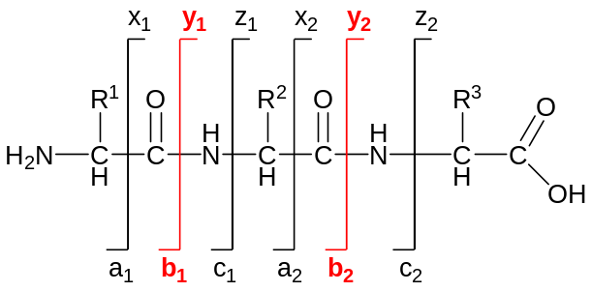

Scheme 1

Figure 1- MS/MS of VAAF (from Huwa)
Formation of b ions

Under the low-energy collision conditions most of the backbone cleavages of the protonated peptides occur in rearrangement type reactions, this is mainly because the excited ions do not have enough energy to fragments on direct bond pathways. Therefore, backbone fragmentation of protonated peptides can be obtained form unspecific pathways.
Charge-directed cleavage of the amide bond is initiated by migration of the added ('mobile proton") proton to amide nitrogen. Several structures have been proposed for the formation of b ion from the dissociation of the amide bond of peptides. Protonation of the amide nitrogen weakens the amide bond and carbonyl carbon of the pronotated amide group becomes a target of a neucleophilic attack from the nearby electron rich groups.

Mechanism of the b ion formation in protonated peptides has widely been discussed in several different pathways. There is still doubt and ambiguity among researchers regarding these mechanisms.

Originally, b ions were assumed to have the acylium structure produced by the direct cleavage of the N-protonated peptide bond proposed by Biemann. ^{Biom Envir Mass Sp1988}
Harrison and co-workers proposed that linear acylium ion is thermodynamically less stable than the isomeric cyclic structures, such as protonated oxazolone derivatives and neutral diketopiperazines. Harrision ^{JASMS 1995,1996}
Later Harrision and Paizs modified the oxazolone pathway occurs trough the ion molecule complex to yield y and b both ions depending on the proton affinity of the species. ^{Harrision JASMS 2003}

Acylium ion pathway (Biemann)

Acylium ion pathway is initiated by mobilization of the additional proton from N-terminal amino group or basic amino acid side chain to “N” of the amide bond to be cleaved which is then followed by the direct bond cleavage leads to formation of a acylium ion and detaching the neutral C-terminal amino acid or truncated peptide from the parent ion (Scheme 3).

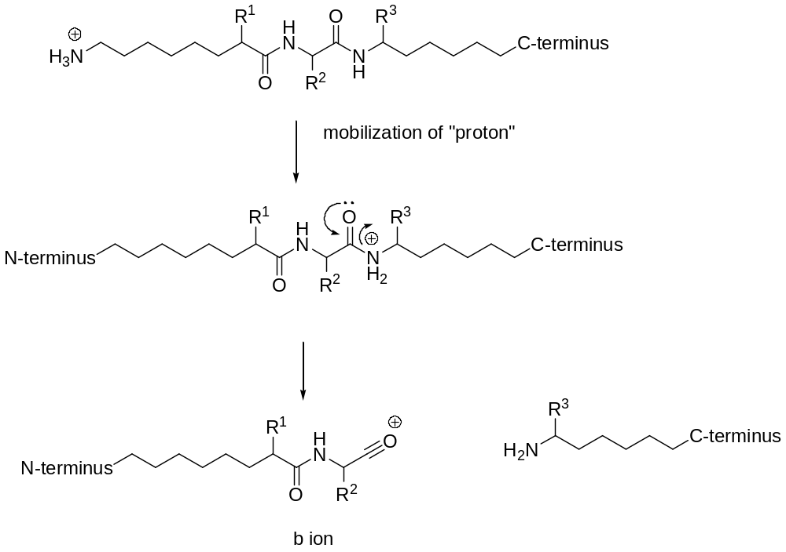
Scheme 2

The question arises why these acylium ions are produced from amino acids are unstable. Normally, acylium ions are stable when those generated from carboxylic acids and their derivatives Scheme 3. This question explored experimentally through CID and metastable ion studies.

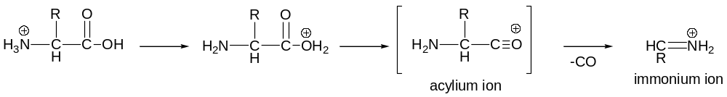

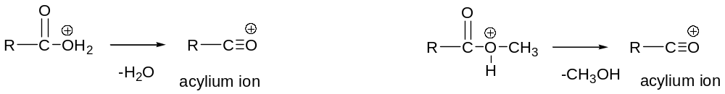

Scheme 3

Oxazolone pathway (Harrison and coworkers)

Oxazolone pathway is initiated by mobilization of the additional proton from N-terminal amino group or basic amino acid side chain to “N” of the amide bond to be cleaved which is then followed by the nucleophilic attack from the N-terminal amide oxygen, on the carbon center of the protonated amide bond leads to formation of a protonated oxazolone derivative and detaching the neutral C-terminal amino acid or truncated peptide from the parent ion (Scheme 4).

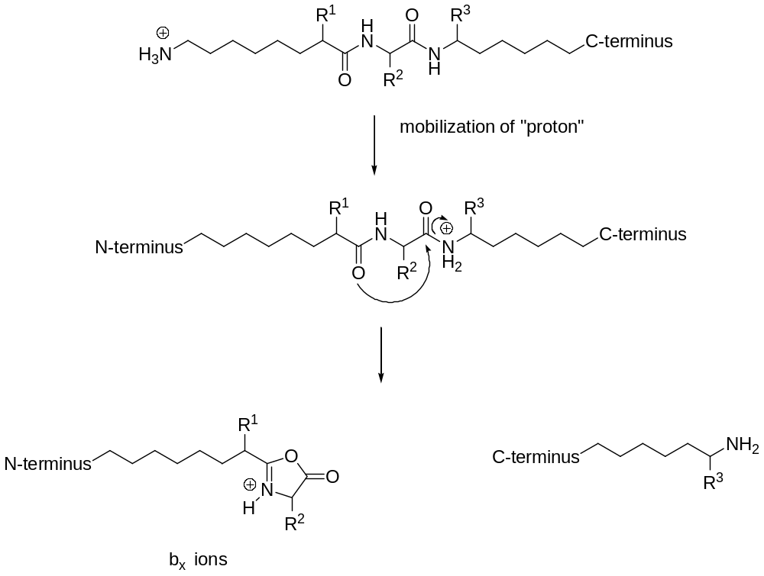

Scheme 4

Most of the experimental results obtained from the structural and energetic studies on small protonated peptides can be explained based on mechanistic considerations involved in the oxzaolone pathway. Harrison and coworkers found that the CID spectra of b-type ion generated from protonated C6H5CO-Gly-Gly-OH matched the CID spectra of protonated 2-phenyl-5-oxazolone supporting the oxazolone structure of the stable b ions.

Modified oxazolone pathway (Paizs and Harrison)

According the modified version, the protonated oxazolone derivative and the leaving C-terminal fragment undergo a rearrangement which results in a proton bound dimer of ion molecule complex. Extra proton is shared by the two monomers, and the dissociation of the proton-bound dimer will depend upon the proton affinities of the species leading to the b_{x} and y_{z} ions (Scheme 5). Trough the ion molecule complex model, both b and y ions can be formed depending their proton affinities.

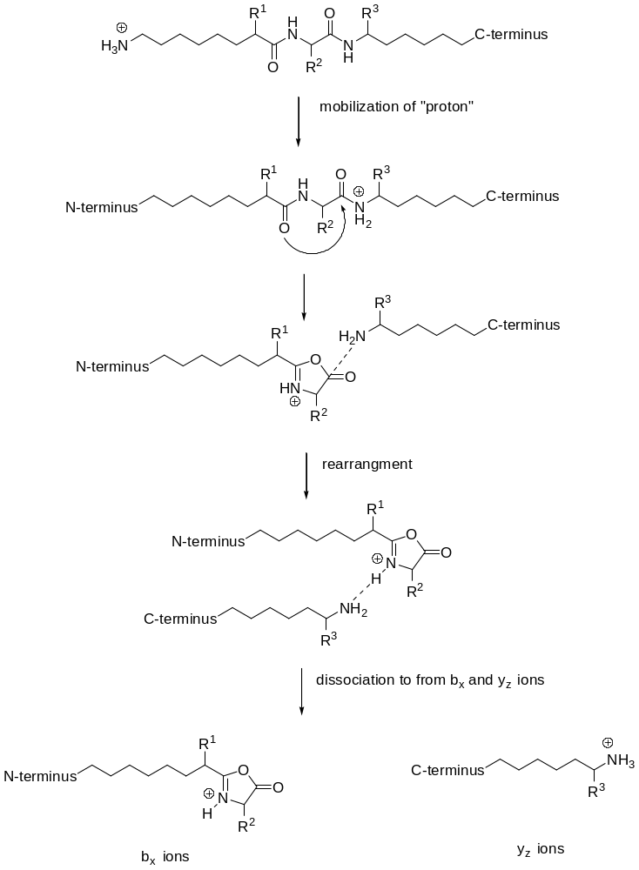

Scheme 5

y ions will not observed whenever oxazolone derivative doesn't have proton to be shared with leaving amino acid or c-terminal truncated peptide supporting to the ion molecule complex model (eg. Gly-Sar-Sar-OH).
If b and y ions are produced by oxazolone and diketopiperazine pathways Gly-Sar-Sar-OH should produced y₁ ion not just the corresponding b ion.

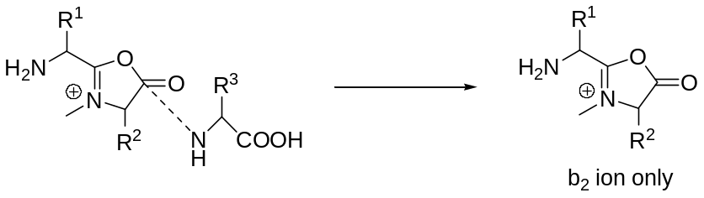

Proposal for the better understanding

