Science Policy Challenges: Managing the Federal S&T Enterprise

BY: Dr. Mark J. Lewis, Ph.D.

ABSTRACT
The Federal Science and Technology enterprise is a vast collection of funding agencies, research laboratories, development centers, spread across a wide range of organizations, from the Department of Defense to the National Science Foundation and National Institutes of Health. Serving in the role as interagency coordinator and facilitator is the White House Office of Science and Technology Policy, which has oversight of the overall balance and completeness of the Executive Branch's science and technology portfolio. This talk will examine some of the challenges faced, and opportunities available, in managing that federal S&T system. Examples will focus on providing the science behind policy decision, as well as the policies required to foster strong science. In particular, the role of independent, objective analysis in informing sound science policy will be highlighted.

BIOGRAPHY
Dr. Mark J. Lewis is the Director of IDA’s Science and Technology Policy Institute, a federally funded research and development center. He leads an organization that provides analysis of national and international science and technology issues to the Office of Science and Technology Policy in the White House, as well as other Federal agencies including the National Institutes of Health, the National Science Foundation, NASA, the Department of Energy, and the Federal Aviation Administration, among others.
Prior to taking charge of STPI, Dr. Lewis served as the Willis Young, Jr. Professor and Chair of the Department of Aerospace Engineering at the University of Maryland. A faculty member at Maryland for 24 years, Dr. Lewis taught and conducted basic and applied research. From 2004 to 2008, Dr. Lewis was the Chief Scientist of the U.S. Air Force. From 2010 to 2011, he was President of the American Institute of Aeronautics and Astronautics (AIAA).
Dr. Lewis attended the Massachusetts Institute of Technology, where he received a Bachelor of Science degree in aeronautics and astronautics, Bachelor of Science degree in earth and planetary science (1984), Master of Science (1985), and Doctor of Science (1988) in aeronautics and astronautics.
Dr. Lewis is the author of more than 290 technical publications and has been an adviser to more than 70 graduate students. Dr. Lewis has also served on various advisory boards for NASA, the Air Force, and DoD, including two terms on the Air Force Scientific Advisory Board, the NASA Advisory Council, and the Aeronautics and Space Engineering Board of the National Academies.
Dr. Lewis’s awards include the Meritorious Civilian Service Award and Exceptional Civilian Service Award; he was also recognized as the 1994 AIAA National Capital Young Scientist/Engineer of the Year, IECEC/AIAA Lifetime Achievement Award, and is an Aviation Week and Space Technology Laureate (2007).

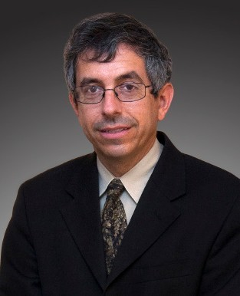
EVENT DETAILS

DATE:
Wednesday, May 27

TIME:
4:00PM – 6:30PM

LOCATION:
Stevens Institute of Technology
Suite G-17
The Ronald Reagan Building
1300 Pennsylvania Avenue, NW
Washington, DC 20004

RSVP:
202-567-6380 or dcops@stevens.edu

