Giving Up Apple in the Name of Repair and the Environment
Lee Vinsel
Feb 26 · 14 min read
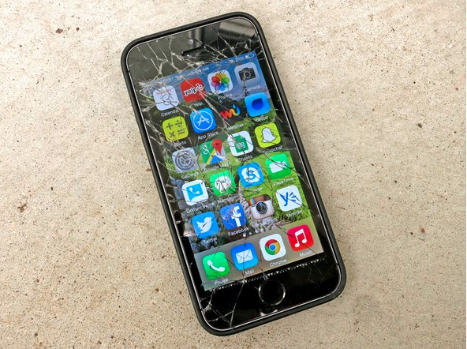
Image courtesy of iFixit
I have been a loyal Apple customer since 2003, when I met the woman who became my wife. When Abigail and I got together, she had an iMac down in her basement bedroom of the house she shared. The blue bubble of a thing looked cutting-edge for its day. I have fond memories of staying up late into the night, buzzing on whatever substances, typing my undergraduate senior thesis into its glowing azure modernity, while Abigail slept on a mattress on the floor a few feet away. The future was then. That iMac was followed by iPods, MacBook Pros, iPads, iPhones, and various iWhatsits and iThingamajigs.
During my long relationship with its products, Apple often did things that frustrated me. Putting Digital Rights Management controls on music purchased through iTunes — a practice discontinued in 2009 — was insane and near-authoritarian, I thought. The company’s penchant for changing the ports on its devices seemingly just to get its customers to buy new dongles and adaptors was maddening and led to many acerbic jokes. (“I can’t find my dongle.” “Hmm, maybe you should lose some weight.”) And I find the iPad’s “sandboxed” nature — in which apps can only access their own data, not data from other apps, leaving the device feeling less like a full-fledged computer than a large phone—needlessly and annoyingly controlling, especially when combined with the company’s drive to keep devices constantly and exclusively tied to its App Store. These frustrations never mounted to the point that I decided to leave behind my iStuff, though.
All that changed this past summer when I set out to write an article about the Right to Repair movement. My path to writing about Right to Repair was not a direct one, though I had been following it for some time. I am one of three co-directors of The Maintainers, a global, interdisciplinary network that draws attention to the importance of maintenance, repair, and the ordinary work that keeps our world going. Initially, my efforts with the network focused on infrastructure and the workers we call “maintainers” — the people who repair and sustain society, who go unrecognized, and who are often too poorly compensated.
But the more I thought through the rich and manifold dimensions of maintenance and repair, the more I also began to consider the maintenance work that goes into our domestic, private lives, including our lives as consumers. An editor at The American Conservative knew that I was following the Right to Repair movement and asked me to write about it for the magazine as part of a series on the dangers of economic concentration for our society. I agreed to write the piece, which was published as “Fighting for the Right to Repair Our Stuff,” because I was excited to reach a new audience. It also gave me the chance to do some research for the book I was co-writing, which will be coming out soon as The Innovator’s Delusion: How Our Obsession with the New Disrupts the Work that Mattered Most. But what I didn’t realize at the time was that writing the piece would also change my inclinations and habits as a consumer. I didn’t see that coming.
If you haven’t been following Right to Repair, the movement focuses on removing repair restrictions, technological and legal barriers that manufacturers use to prevent consumers and independent repairpersons from fixing their products. Repair restrictions can take many forms, including designing uncommon screwheads that you are unlikely to own a tool for; using software controls on products, which, for example, show error codes you do not understand; not making repair manuals publicly available; and limiting access to spare parts.
Over the past few decades, repair restrictions have become more or less the industry standard — now ubiquitous, especially in electronics, computing, and appliance industries. One reason for this recent increase is that software, which is built into ever-increasing numbers of our objects, gives manufacturers much more power to lock their products against repair. And they are using that power against us.
Much of the energy behind the Right to Repair movement arises from a belief in consumer rights and and a sense of righteous indignation that, even though we own a product, we are not free to repair our own stuff. For example, Right to Repair advocates highlight the stories of farmers who are unable to fix their John Deere tractors without calling for expensive and time-consuming aid from dealerships and approved repair technicians. Facing these restrictions, “farmers are buying 40-year-old tractors because they’re actually repairable,” as the title of a recent article put it. It’s crucial to remember, though, that repair restrictions affect not only individual consumers but also businesses and even the US military. Corporate control over repair is exacting a large — though as yet uncounted — cost on our society.
But the importance of Right to Repair goes well beyond the right to repair our property, as important and fundamental as that is. Broken, unrepaired electronics are an enormous environmental problem. Americans dispose of about 416,000 cellphones a day, or 151 million phones a year. Manufacturers use a number of “endangered” elements to produce these devices, including at least 5 elements that could run out within 100 years if we continue to consume them at current levels. Our activities are literally unsustainable. Moreover, the climate ramifications of our system of producing and using computers, phones, and other electronics are staggering. As one article put it, “Buying a new smartphone consumes as much energy as using an existing phone for an entire decade.” For the good of our planet, we must keep our devices alive for as long as possible.

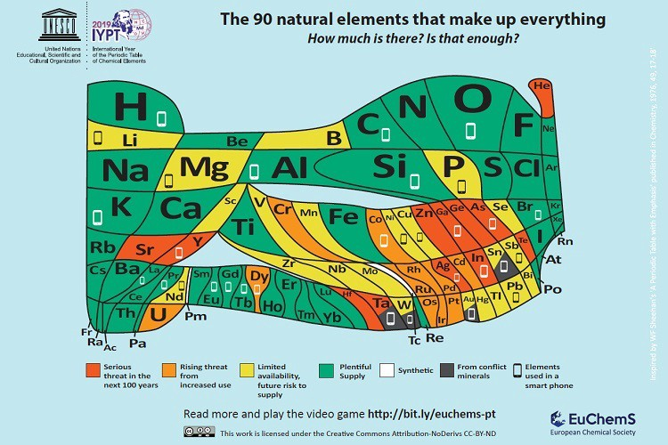
This new periodic table, made by at team at the University of St. Andrew, highlights the availability and vulnerability of elements. The small rectangles denote elements used in smartphones.
Coming to understand the Right to Repair movement, among other things, meant interviewing what some people call the “triumvirate,” three leaders who have been setting the agenda and raising awareness around repair restrictions for years now: Nathan Proctor who leads Right to Repair efforts at US PIRG; Gay Gordon-Byrne, the executive director of The Repair Association, a trade association that represents repair shops; and Kyle Wiens, Editor-in-Chief of iFixit, an online repair guide website. Nathan, Gay, and Kyle were generous, sharing their time and experiences with me as I worked to put the puzzle of my article together.
As I talked to the triumvirate and did other research, I noticed that Apple kept coming up. Initially, I thought advocates used Apple as an example because the company is famous and iconic and because its use of repair restrictions is clear and communicable. But the deeper I went into research and writing, the more and more something was dawning on me. For while, I think I didn’t even want to see it, but after a while it was irrefutable: Champions of Right to Repair weren’t just picking on Apple because it is an easy target (let’s face it, Apple has always had its haters). Something deeper was going on. No, people kept bringing up Apple because Apple was what the regulatory and legal worlds call a bad actor — a company with a known and established pattern of unethical behavior.
After months of following this topic, I now know that there is a long list of ways in which Apple is terrible on repairability and Right to Repair. But here I would like to focus on four categories of bad action:
First, Apple’s products typically score quite low in rankings of repairability, such as the ones created at iFixit. For example, iPads are repair disaster zones, including because their innards feature “gobs of adhesive holding many parts and cables in place, complicating all repairs.” iPads often receive a 2 out of 10 in iFixit’s repairability scores, whereas the HP Elite x2 gets a 10 out of 10 because it has an “easy opening procedure” and a “simple, modular, glue-free design.”
The lack of repairability and recyclability in Apple’s products is a choice. For instance, in some devices, Apple has glued glass to aluminum. As Wiens of iFixit once wrote, “The design may well be comprised of ‘highly recyclable aluminum and glass’— but my friends in the electronics recycling industry tell me they have no way of recycling aluminum that has glass glued to it.” Apple is designing products to be unrepairable, unrecyclable, and end up in the dump.
Second, Apple has introduced cryptographic software controls to ensure that repairs — such as replacing screens and batteries — are not only done with Apple certified parts but also done by Apple certified repair people. Apple began this trend with logic boards and Touch ID sensors, which, if replaced, require the repair person to run a “proprietary diagnostic tool” that only Apple certified repairpersons have. These software locks are intentionally built into products. In other words, Apple engineers are making specific choices to design the product such that it can lock out repair. Apple then extended cryptographic locks to batteries and screens. Even if you put a genuine Apple screen on an iPhone but you do it yourself or hire a repairperson who is not certified by Apple to do it, you will get error messages like these:

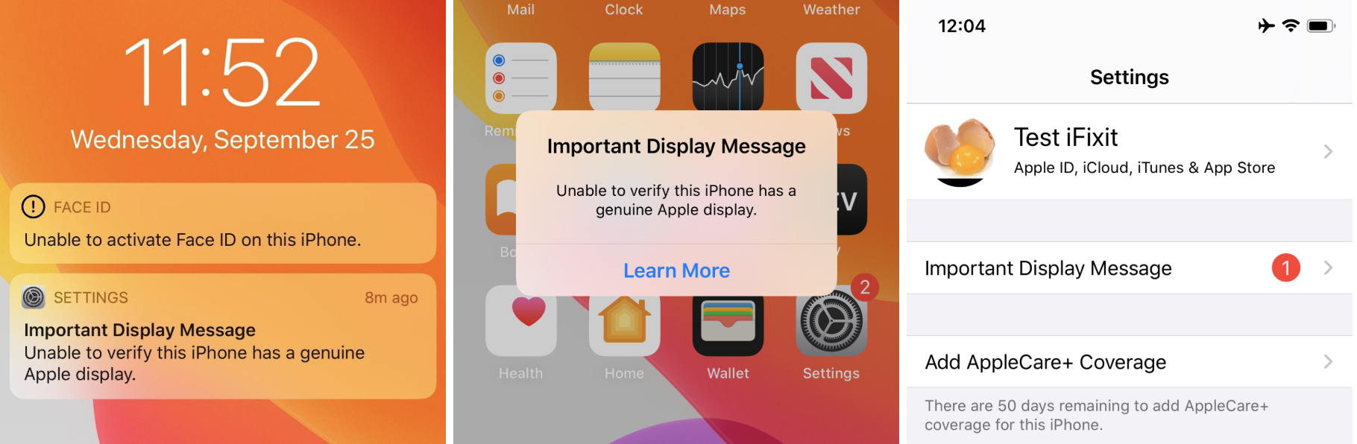
Images courtesy of iFixit
With batteries — again, even if you replace your current iPhone battery with a genuine iPhone battery—you will get error messages, “the phone will never show its battery health, and [will] always report a vague, ominous problem.” In other words, the company is asserting monopoly control over both parts and repair work. Among other things, these controls can have big consequences for us as consumers because Apple can charge you $1,000 or more than a local repair shop will for some repairs.
Third, recycling is never as efficient as keeping an object in use. The best thing we can do for the environment is keep devices in play for as long as possible. Yet, Apple has a history of cracking down on third-party refurbishers. Apple requires recyclers working on its products to shred MacBooks, iPhones, and other devices “into tiny shards of metal and glass” rather than follow industry best practice and harvest them for parts that could be used to repair other devices and keep them going. Apple also successfully pushed Amazon to remove unauthorized refurbishers from its marketplace. A point I will return to below: Apple’s interests here are clear. Used products compete with new products, and Apple makes most of its profit from selling new stuff. By cracking down on refurbishers, it keeps competitors at bay, even though doing so goes against our interest as consumers and the health of the planet.
Four, the Right to Repair movement has introduced legislation in over 20 states that would go a long way to opening up repair to consumers and small business owners. Gay Gordon-Byrne says that Right-to-Repair requires a “five-legged stool” approach. To do a repair, you or someone you hire needs: 1) a manual; 2) parts; 3) tools, especially given that companies use odd-shaped, specialized parts to limit access; 4) the ability to read and understand computerized diagnostics, including knowledge of what the strange error codes that appear on our gadgets mean; and 5) access to firmware (low-level software used to control hardware) and passwords that manufacturers use to lock down repair. Without these five things, it is extremely difficult for owners to fix their own property, and the aftermarket cannot thrive. Right to Repair laws require manufacturers to make the five-legged stool available.
Apple is one of the fiercest and most powerful critics of Right to Repair legislation, and it has poured money into lobbying against the laws. The company makes the specious and unevidenced argument that it opposes Right to Repair for safety reasons — because consumers and unauthorized repair people, supposedly, might hurt themselves while replacing batteries. But Apple does not provide proof this such injuries have ever happened. Lobbyists for Apple also told Nebraska lawmakers that if they passed Right to Repair legislation, it would make the state a “mecca” for hackers. As Wiens of iFixit put it to me, “Apple is increasingly standing alone as the electronics company lobbying against right to repair.”
In August 2019, Apple announced that it would begin selling parts, tools, and diagnostic software to independent repair shops, in what many saw as a concession to Right to Repair pressures. But when journalists got ahold of the contract Apple required of these independent businesses, they found that the contract contained a number of stipulations that Right to Repair advocates described as “onerous” and “crazy.” For example, the shops must agree to allow Apple to do unannounced audits and inspections, even up to five years after the shop leaves Apple’s program. Among other things, these inspections would focus on making sure the repairpersons are using only Apple certified parts. Participating independent repair shops are also required to repeatedly tell customers that they aren’t authorized Apple repair stores. As Proctor of US PIRG put it, this “is like going to a normal repair shop except one that advertises against [itself] at every possible moment.”
Advocates assert that, through this independent repair program, Apple is trying to appear to have answered the criticisms of Right to Repair, even though the program is nowhere close to a true Right to Repair. Some have critics have taken to calling Apple’s repair program “repair-washing,” a play on greenwashing, the corporate use of environmental language and images that stray from reality. (Apple also greenwashes, by the way. It constantly plays up its sustainability programs but these focus only on production. The company fails to mention what happens to its products when they are out in the world.)
When you add all of this up — the product design, the software controls, the crackdowns on refurbishing, the lobbying, the bullshit repair programs that don’t even begin to solve the problem — it is clear that Apple has an avowedly anti-repair ethic. This anti-repair ideology comes at a cost not just of the rights of consumers and organizations to control their property but also in a huge environmental toll.
At some point, the cognitive dissonance got to be too much for me. I found that I could no longer be an advocate for maintenance, repair, and the environment and be an Apple customer. Something had to go. When I decided to get a tablet computer for work late last year, I bought my first non-Apple product in a long, long time. I continue to use an iPhone and Macbook and I will keep them alive for as long as I can, but they will be the last Apple devices I own until the company changes its ways. When I set out to write my article, I never imagined I would come out different at the end of it. I don’t want to be overly dramatic and act like deciding what phone or computer you buy is some big life change, but I found that I wasn’t the same consumer I was after looking into Right to Repair.
Apple’s reasons for restricting repair are self-evident: the company increases its value by selling more products, and keeping devices going longer would reduce sales. Indeed, in January 2019, Apple’s stock took a hit when it announced that its sales had underperformed. In a letter to shareholders, Apple president Tim Cook said that one reason that growth failed to meet expectations because some customers were “taking advantage of significantly reduced pricing for iPhone battery replacements.” The cheaper battery prices resulted from a brouhaha when it came out that the company was slowing down phones with old batteries. As a response to public outcry, the company offered to replace batteries for $29, and customers took advantage of the program. Cook’s message? Increased repair of existing phones was cutting into sales of new ones.
If it isn’t obvious, Apple puts us all on a collision course with the health of our planet through this growth-at-all costs imperative. Of course, Apple isn’t alone in this. E-waste is an enormous problem, bigger than any one corporation. But by clamping down on repair and making unrepairable devices, Apple does even more than other corporations to speed its products paths into landfills. Moreover, as a powerful cultural and business leader, Apple sends exactly the wrong environmental message to its industry and society at large. The company’s leaders could be voices for sustainability and a road forward for consumer electronics. Instead they choose moral darkness.
Apple is a rich company. In August 2018, it became the first American public corporation to reach $1 trillion in capitalization, hitting $1.3 trillion a little over a year later. If it wanted to make repairability a prerogative, it certainly could. AirPods — Apple’s Bluetooth headphones—are a wonderful example of how the company chooses an unsustainable path. As journalist Caroline Haskins put it in a viral article titled, “AirPods Are a Tragedy,” “For roughly 18 months, AirPods play music, or podcasts, or make phone calls. Then the lithium-ion batteries will stop holding much of a charge, and the AirPods will slowly become unusable. They can’t be repaired because they’re glued together. They can’t be thrown out, or else the lithium-ion battery may start a fire in the garbage compactor. They can’t be easily recycled, because there’s no safe way to separate the lithium-ion battery from the plastic shell. Instead, the AirPods sit in your drawer forever.”
In other words, AirPods are a literal dumpster fire — at least a potential one. The headphones are so unsustainable on an environmental front, Wiens of iFixit described them as “evil.” Compare AirPods to Samsung’s Galaxy Buds, earbud headphones that iFixit has described as “surprisingly repairable.” Again, Apple chooses to make unrepairable products.
The fact that Apple is making such choices is nicely brought out by a Mac Pro Apple released in late 2019. iFixit did a teardown and found that the modular machine was highly repairable, describing it as a “Fixmas Miracle.” The Mac Pro is a reason for hope, and it would be wonderful if it was part of an overall trend at Apple. But for now, it appears to have been a fluke. As Wiens told me, the Mac Pro “shows that there are people inside Apple who know how to do the right thing. We have to keep up the pressure so that they expand this approach to their other products.”
I think that the ultimate solution to maintainability and sustainability is regulation. Regulation can generate socially-beneficial innovation, as I argued in my book on the history of automobile regulation. Repairability and recyclability seem to be good candidates for this approach. We will need laws that require our products to be repairable and truly recyclable to reduce our burden on the planet. Right to Repair legislation would be an important step down this road.
But in the meantime, we can vote with our pocketbooks and do our part as consumers. We should support companies that choose to prioritize repair and repairability, and we should avoid companies that do not. (Repairability scores, like the ones at iFixit, are a good tool for guiding your purchases.)
As a historian of business and government, I have been trained never to view organizations as monoliths. No doubt, there are individuals within Apple who care about consumer rights and Earth’s future and who are frustrated with their leaders. We shouldn’t paint the entire company with the same brush, and we should partner with people within it to advocate for change wherever and whenever we can. But for the time being, the company’s policies and practices are indefensible and worthy of boycott.
For now, until things change, I’m giving up Apple in the name of repair and the environment, and I encourage others to do the same.

